Part of the Branches Education Group
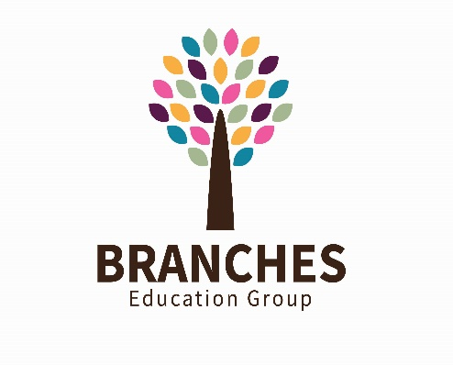

SEND POLICY
Approved By | R Warhurst | Head Teacher | Aug 2026
Amendments Made
Linked Policies
Signed | R Warhurst | Head Teacher | Aug 2026
Signed | L De Hayes | Governance Chair | Aug 2026
Date Next Review | Aug 2027

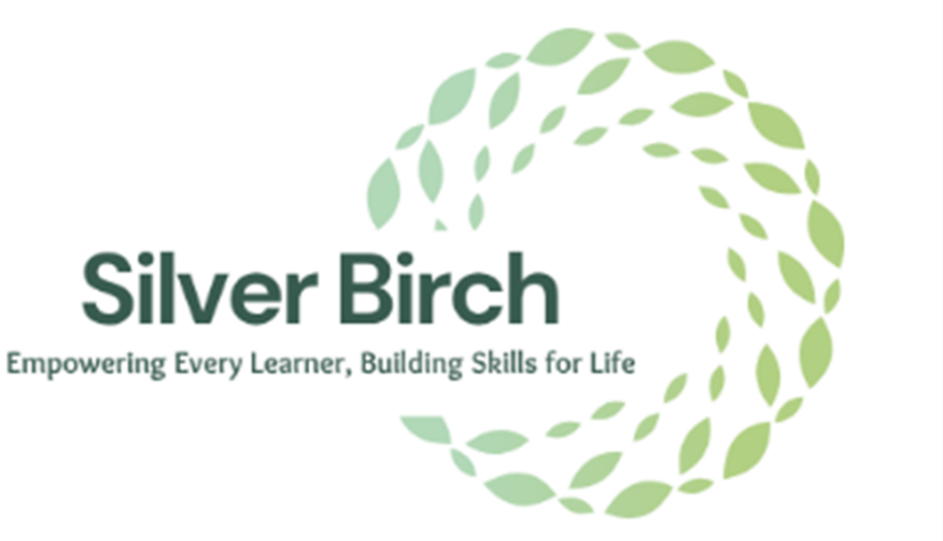

CONTENTS
1.0 BACKGROUND 3
1.1 Aims 3
1.2 References 3
2.0 OUR PROVISION FOR S.E.N.D. 3
2.1 Specific Learning Difficulties (SpLD) 4
2.2 Speech, Language and Communication Needs (SLCN) 4
2.3 Autism 4
2.4 Moderate Learning Disability (MLD) 5
2.5 Social, Emotional and Mental Health Needs, including Attachment and Trauma 5
3.0 OUR COMMITMENT 5
3.1 Branches Education Group 5
3.2 Silver Birch School 6
3.3 Our Approach to Learning 6
4.0 REFERENCES AND FURTHER READING 7

1.0 BACKGROUND
Silver Birch School is committed to providing a high-quality, inclusive education that meets the individual needs, strengths, and aspirations of every pupil. We recognise the significant role education plays in improving life chances, promoting independence, and enabling pupils to achieve positive outcomes throughout their lives.
All pupils attending Silver Birch School have Special Educational Needs and/or Disabilities (SEND). All pupils have an Education, Health and Care Plan (EHCP). Many pupils present with additional and often complex needs that may change over time. We are committed to understanding each pupil's individual profile and adapting provision accordingly to ensure that support remains appropriate, effective, and responsive to changing needs.
This policy has been developed in line with current legislation and statutory guidance. The school assesses and reviews pupils' needs on admission and regularly thereafter, working in partnership with pupils, parents/carers, local authorities, and other professionals. The effectiveness of provision is monitored and reviewed to ensure it remains appropriate, supports progress, and enables pupils to achieve the outcomes identified within their EHCPs.
The school is committed to promoting the welfare, safety, and wellbeing of all pupils and will ensure that SEND provision is delivered in accordance with safeguarding requirements outlined in Keeping Children Safe in Education (KCSIE) 2026.

1.1 Aims
Our aims are to support all pupils to:
- Develop personally, socially, emotionally, and academically.
- Achieve their full potential and make sustained progress from their individual starting points.
- Build confidence, resilience, independence, and self-advocacy skills.
- Access an ambitious and appropriate curriculum that meets their individual needs.
- Prepare successfully for adulthood, including further education, employment, independent living, community participation, and good health.
- Leave school with a range of qualifications, experiences, knowledge, and skills that support positive future outcomes.
1.2 References
This policy has been written with regard to:
- Children and Families Act 2014, Part 3.
- Special Educational Needs and Disability Regulations 2014.
- Special Educational Needs and Disability Code of Practice: 0 to 25 Years (January 2015).
- Equality Act 2010.
- Autism Act 2009.
- Keeping Children Safe in Education (KCSIE) 2026.
- Working Together to Safeguard Children (2023).
- The Independent School Standards Regulations 2014 (as amended).
- United Nations Convention on the Rights of the Child (UNCRC).
- United Nations Convention on the Rights of Persons with Disabilities (UNCRPD).
Clinical Guidance
- National Institute for Health and Care Excellence (NICE) Guideline NG170: Autism Spectrum Disorder in Under 19s: Support and Management.
- National Institute for Health and Care Excellence (NICE) Guideline CG128: Autism Spectrum Disorder in Under 19s: Recognition, Referral and Diagnosis.

2.0 OUR PROVISION FOR SEND
Silver Birch School provides specialist education for pupils with a range of complex special educational needs and disabilities (SEND). These include, but are not limited to:
- Specific Learning Difficulties (SpLD), including Dyslexia, Dyspraxia (Developmental Coordination Disorder), Dyscalculia, Dysgraphia, and Attention Deficit Hyperactivity Disorder (ADHD).
- Speech, Language and Communication Needs (SLCN).
- Autism Spectrum Condition (ASC) / Autism.
- Moderate Learning Difficulties (MLD).
- Social, Emotional and Mental Health (SEMH) needs, including those associated with attachment difficulties, trauma, and adverse childhood experiences.
The school provides highly personalised learning programmes, specialist resources, and enhanced staffing ratios to ensure that pupils receive the support they require to access learning, make progress, and achieve positive outcomes. Our experienced multidisciplinary team works collaboratively with pupils, families, local authorities, and external professionals to ensure provision remains responsive to each pupil's changing needs and aspirations.

2.1 Specific Learning Difficulties (SpLD)
Specific Learning Difficulties (SpLD) affect particular aspects of learning while an individual may demonstrate age-appropriate or above-average ability in other areas. SpLDs can impact literacy, numeracy, coordination, organisation, memory, processing speed, and attention.
Common SpLDs include:
- Dyslexia.
- Dyspraxia (Developmental Coordination Disorder).
- Dyscalculia.
- Dysgraphia.
- Attention Deficit Hyperactivity Disorder (ADHD).
Every pupil's profile is unique, and difficulties can present in different ways and to varying degrees. We adopt a strengths-based approach, recognising pupils' abilities and talents whilst providing targeted support and reasonable adjustments to address areas of need.
2.2 Speech, Language and Communication Needs (SLCN)
Speech, Language and Communication Needs (SLCN) describe difficulties with speech production, understanding and using language, social communication, or a combination of these areas.
Pupils with SLCN may experience challenges with:
- Understanding spoken language and instructions.
- Expressing thoughts, feelings, and ideas.
- Social interaction and conversational skills.
- Listening, attention, and processing information.
- Understanding social cues and non-verbal communication.
Every pupil with SLCN will have their own strengths and areas of need. The school provides tailored support and communication strategies to help pupils develop confidence, independence, and effective communication skills.

2.3 Autism
Autism is a lifelong neurodevelopmental difference that influences how an individual experiences, communicates with, and interacts with the world around them. Autism is a spectrum condition, meaning every autistic person has a unique profile of strengths, preferences, and support needs.
Autistic pupils may experience differences in:
- Social interaction and relationship building.
- Verbal and non-verbal communication.
- Flexibility of thinking and adapting to change.
- Processing information and understanding abstract concepts.
- Managing uncertainty and unfamiliar situations.
Many autistic pupils may also experience sensory differences, which can include heightened or reduced sensitivity to sounds, sights, smells, tastes, touch, movement, temperature, or other environmental factors. These sensory experiences can affect wellbeing, learning, emotional regulation, and behaviour.
Some autistic pupils may engage in self-regulatory behaviours, often referred to as "stimming", which can help them manage sensory input, emotions, and anxiety. The school recognises the importance of understanding and supporting these behaviours appropriately.
We also recognise that some autistic pupils, particularly girls and young women, may mask or camouflage difficulties in social situations. While this can make challenges less visible, it may lead to increased anxiety, exhaustion, stress, and reduced wellbeing. Staff are trained to recognise and respond sensitively to the differing presentations of autism.

2.4 Moderate Learning Difficulties (MLD)
Pupils with Moderate Learning Difficulties (MLD) typically experience greater difficulty than their peers in acquiring and applying literacy, numeracy, communication, and wider curriculum skills.
Pupils with MLD may:
- Progress at a slower rate than expected across a range of curriculum areas.
- Require additional repetition, consolidation, and overlearning.
- Experience difficulties with memory, processing, problem solving, and reasoning.
- Need support to develop independence and social skills.
- Experience associated speech, language, and communication difficulties.
Provision is adapted to meet individual learning needs through a personalised curriculum, targeted interventions, and appropriate support strategies.

2.5 Social, Emotional and Mental Health (SEMH) Needs, Including Attachment and Trauma
Social, Emotional and Mental Health (SEMH) needs can affect how pupils understand and manage emotions, build relationships, engage with learning, and respond to everyday experiences.
Some pupils may have experienced adverse childhood experiences, trauma, disrupted attachments, bereavement, family difficulties, or other circumstances that impact their emotional wellbeing and development.
Pupils with SEMH needs may:
- Experience anxiety, low mood, or emotional dysregulation.
- Find it difficult to manage strong emotions.
- Experience challenges with social relationships and trust.
- Become withdrawn or isolated.
- Demonstrate behaviours that communicate distress, unmet needs, or difficulties with emotional regulation.
Some pupils may present with attachment difficulties resulting from experiences that have affected their ability to develop secure relationships. These pupils may require consistent relationships, predictable routines, emotionally available adults, and specialist support to help them develop trust, resilience, and a sense of safety.
Silver Birch School adopts a trauma-informed and relational approach, recognising that behaviour is a form of communication. We seek to understand the underlying causes of behaviour, promote emotional wellbeing, and provide supportive interventions that enable pupils to thrive both academically and personally.

3.0 OUR COMMITMENT
3.1 Branches Education Group
Branches Education Group will support the Headteacher and school to:
- Promote equality, diversity, inclusion, and equality of opportunity for every pupil.
- Provide a caring, respectful, nurturing, and safe environment in which all pupils can learn, develop, and thrive.
- Listen to and value the views, wishes, and feelings of pupils, ensuring they are involved in decisions affecting their education and wellbeing.
- Promote dignity, independence, self-respect, and positive self-esteem.
- Maintain high aspirations for every pupil and support them to achieve their full potential.
- Ensure appropriate resources, staffing, and specialist support are available to meet individual needs.
- Provide a broad, balanced, ambitious, and relevant curriculum that is adapted where necessary to meet pupils' individual needs.
- Work in partnership with parents, carers, commissioners, local authorities, and external professionals to secure the best possible outcomes for pupils.
- Monitor pupil progress, attainment, attendance, wellbeing, and outcomes, ensuring parents, carers, and relevant professionals receive regular updates.
- Assess pupils' needs following admission and review provision regularly to ensure support remains appropriate and effective.
- Monitor and evaluate SEND provision to ensure it supports progress towards EHCP outcomes and wider preparation for adulthood.
- Ensure there is an appropriately qualified and experienced Special Educational Needs Coordinator (SENCO) who fulfils statutory duties and supports staff across the school.
- Provide ongoing professional development and specialist training to ensure staff understand pupils' needs and are equipped to deliver the highest standards of practice.
- Promote safeguarding and pupil welfare through all aspects of school life, in accordance with current statutory guidance.

3.2 Silver Birch School
The Headteacher will support the staff team to:
- Develop a thorough understanding of each pupil's strengths, needs, interests, aspirations, and EHCP outcomes.
- Plan and implement personalised transition arrangements to support pupils joining the school.
- Ensure that all pupils feel safe, valued, respected, and able to participate fully in school life.
- Undertake baseline assessments and ongoing assessments to identify needs and measure progress.
- Ensure pupils receive therapeutic, clinical, and specialist provision specified within their EHCPs and individual plans.
- Promote understanding, respect, equality, diversity, and inclusion throughout the school community.
- Deliver an ambitious curriculum that is appropriately adapted to meet individual needs.
- Use assistive technology, communication aids, and other supportive resources where appropriate.
- Monitor and record academic, social, emotional, and personal development and report progress regularly to parents, carers, commissioners, and relevant professionals.
- Actively seek, value, and respond to pupil voice when planning provision and support.
- Work collaboratively with parents, carers, local authorities, therapists, and other professionals.
- Set meaningful short-term targets that contribute towards achieving longer-term EHCP outcomes.
- Implement evidence-informed interventions and personalised support strategies.
- Promote preparation for adulthood through the development of independence, communication, social skills, employability skills, and community participation.
3.3 Our Approach to Learning
We recognise that every pupil is unique and learns in different ways. Our approach is centred on understanding individual strengths, needs, interests, and aspirations so that pupils can achieve success and make meaningful progress.
To support effective learning, we will:
- Personalise learning programmes and timetables to meet individual needs, interests, and EHCP outcomes.
- Employ skilled, qualified, compassionate, and committed staff who share high expectations for all pupils.
- Provide a safe, structured, welcoming, and stimulating learning environment.
- Support the development of communication, social, emotional, independence, resilience, and life skills alongside academic achievement.
- Provide opportunities for learning within the local community and wider society to support citizenship and preparation for adulthood.
- Deliver a broad range of educational experiences, including physical education, outdoor learning, cultural experiences, enrichment activities, careers education, and work-related learning where appropriate.
- Promote positive social interaction and relationship building through structured and unstructured opportunities throughout the school day.
- Adopt neurodiversity-affirming approaches and provide appropriate adjustments, including visual supports, social narratives, communication systems, sensory strategies, and structured routines where these support individual pupil needs.
- Foster independence, self-advocacy, and confidence so that pupils are increasingly able to understand and express their own needs.
- Celebrate achievement, effort, progress, and personal success in all its forms.
- Work within a trauma-informed and relational framework that recognises behaviour as a form of communication and promotes positive wellbeing.

4.0 REFERENCES AND FURTHER READING
- Statutory Legislation and Guidance
- Children and Families Act 2014.
- Equality Act 2010.
- Special Educational Needs and Disability Regulations 2014.
- Special Educational Needs and Disability Code of Practice: 0 to 25 Years (January 2015).
- Keeping Children Safe in Education (KCSIE) 2026.
- Working Together to Safeguard Children (2023).
- Supporting Pupils at School with Medical Conditions, Department for Education.
- Careers Guidance and Access for Education and Training Providers: Statutory Guidance (2026), where relevant to preparation for adulthood and careers provision.
- SEND and Inclusion
- Department for Education, SEND and Alternative Provision Improvement Plan (2023).
- SEND Review: Right Support, Right Place, Right Time (2022).
- Autism Act 2009.
- National Institute for Health and Care Excellence (NICE):
- NG170 Autism Spectrum Disorder in Under 19s: Support and Management.
- CG128 Autism Spectrum Disorder in Under 19s: Recognition, Referral and Diagnosis.
- Quality Standard QS51: Autism.
- Inspection and Quality Assurance
- Ofsted: School Inspection Handbook (current version).
- Ofsted: SEND Research Reviews and Current SEND Guidance.
- The Independent School Standards Regulations 2014 (as amended).
- Professional Resources
- Autism Education Trust (AET): https://www.autismeducationtrust.org.uk
- Autism Education Trust Progression Framework.
- BILD Learning Disability Professional Development Framework.
- Blackburn with Darwen Local Offer: https://www.bwd-localoffer.org.uk
- Recommended Further Reading
- The Reason I Jump - Naoki Higashida.
- Publications and resources from the Autism Education Trust.
- Evidence-informed publications relating to trauma-informed practice, attachment, emotional wellbeing, and neurodiversity.

