Part of the Branches Education Group


Approved By | R Warhurst | Head Teacher | Aug 2026
Amendments Made
Linked Policies
Signed | R Warhurst | Head Teacher | Aug 2026
Signed | L De Hayes | Governance Chair | Aug 2026
Date Next Review | Aug 2027
FOOD POLICY
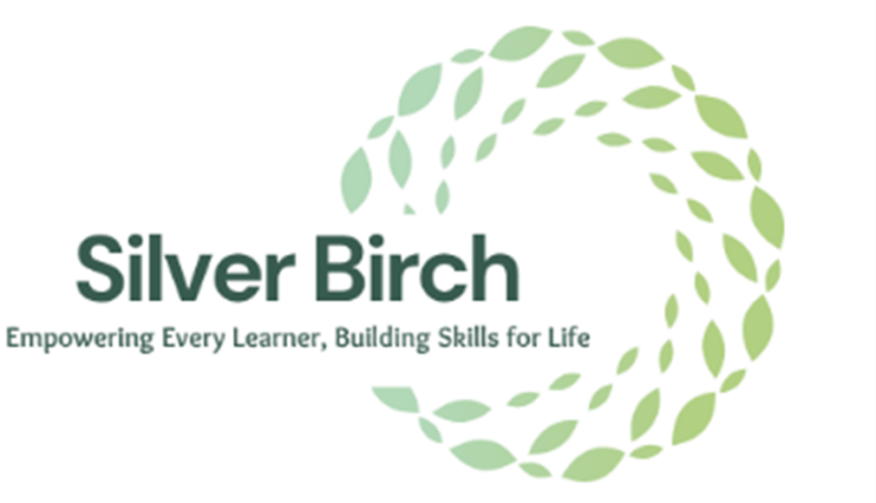

At Silver Birch School, we believe that mealtimes should be safe, enjoyable and social occasions where pupils and staff can interact positively in a relaxed and supportive environment. Mealtimes are viewed as an important part of the school day and provide opportunities to promote independence, communication, social skills and healthy lifestyles.
We are committed to providing healthy, nutritious and balanced meals and snacks that meet the individual needs, preferences and dietary requirements of all pupils.
The school will ensure that:

• Pupils are provided with a light breakfast, nutritious breaktime snacks and a midday meal each school day.

• Menus are planned in advance and reflect the principles of healthy eating. Menus are reviewed regularly, provide variety and take account of cultural, religious and dietary requirements.

• Menu information, including allergen information, is available to pupils, parents and carers.

• Meals and snacks provide a balance of nutrients and minimise excessive amounts of saturated fats, salt, sugar, artificial additives, preservatives and colourings wherever possible.

• Fresh fruit and vegetables are offered daily as part of a balanced diet.

• Fresh drinking water is freely available and accessible throughout the school day. Pupils are encouraged to maintain appropriate hydration, particularly during periods of hot weather or increased physical activity.

• Information regarding dietary needs, food allergies, intolerances, cultural preferences, religious requirements and medical conditions is obtained before admission and reviewed regularly.

• Individual risk assessments, healthcare plans and dietary management plans are implemented where necessary to support pupils with allergies, intolerances or medical conditions affecting eating and drinking.

• Food preparation and serving arrangements take account of allergen management requirements and reasonable steps are taken to prevent cross-contamination.

• Staff maintain a respectful and inclusive approach to all dietary requirements and ensure that pupils are not singled out, labelled or treated differently because of their dietary needs.

• Cultural, religious and lifestyle dietary preferences are respected and accommodated wherever reasonably practicable.

• Pupils are given sufficient time to eat at a comfortable pace and are encouraged to develop independence and positive eating habits.

• Portion sizes are appropriate to pupils' age, developmental stage and individual needs.
• Staff model positive eating behaviours, appropriate table manners and respectful social interaction during mealtimes.

• Healthy eating and nutritional awareness are promoted through the curriculum, daily routines and discussions with pupils.

• Additional support is provided for pupils who experience difficulties with eating, drinking, food textures, sensory preferences, swallowing or feeding skills. Advice from relevant healthcare professionals will be followed where appropriate.

• All staff involved in food preparation, handling and service are suitably trained and competent to undertake their duties. Food hygiene training is refreshed regularly in accordance with legal requirements and best practice.

• Food preparation, storage and serving arrangements comply with relevant food safety and hygiene legislation.

• The school regularly reviews its catering arrangements and seeks feedback from pupils, parents and staff to support continuous improvement.

