Part of the Branches Education Group
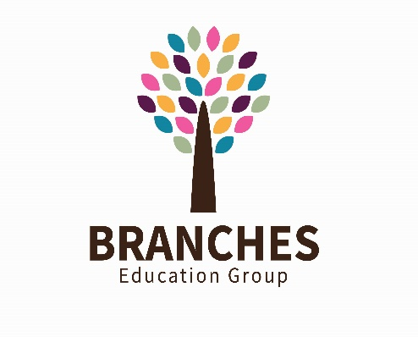

CAREERS WORK RELATED LEARNING POLICY
Approved By | Rebecca Warhurst | Head Teacher | Aug 2026
Amendments Made
Linked Policies
Signed | R Warhurst | Head Teacher | Aug 2026
Signed | L De Hayes | Governance Chair | Aug 2026
Date Next Review | Aug 2027
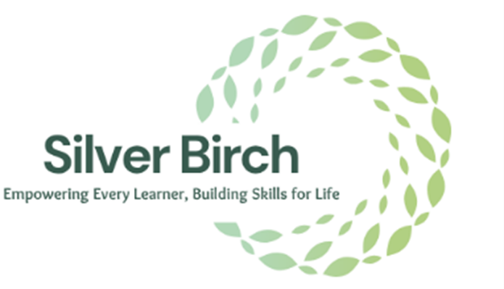

CONTENTS

1.0 INTRODUCTION 3
1.1 Background 3
1.2 Definitions 3
1.3 The Gatsby Benchmarks 3
1.4 Meeting Required Guidance and Standards 4
2.0 CAREERS ACROSS THE KEY STAGES 4
2.1 Primary/ Lower School Pupils 4
2.2 Secondary/ Upper School Pupils 5
3.0 CAREERS PROGRAMME – CURRICULUM INTENT 6
4.0 REFERENCES 6
5.0 APPENDIX 1 - CAREERS PROGRAMME CURRICULUM MAP 8

1.0 INTRODUCTION
1.1 Background
At Branches Education Group, we are passionate about helping pupils identify and realise their ambitions and aspirations to secure futures that are right for them as individuals. Whether pupils aspire to become astronauts, artists, skilled tradespeople, entrepreneurs, or are uncertain about their future pathways, we will support them to recognise their strengths, talents, interests, and areas for development.
Our careers programme is designed to equip pupils with the knowledge, skills, experiences, and confidence needed to make informed decisions about their future education, employment, and training opportunities. We recognise that aspirations and circumstances may change over time and are committed to developing pupils' resilience, adaptability, and transferable employability skills so that they can successfully navigate an evolving labour market.
We embrace our responsibility to ensure that all pupils are prepared for the next stage of their education, employment, or training and are able to access sustainable pathways that support their long-term career ambitions and personal development. Our careers provision promotes equality of opportunity, raises aspirations, challenges stereotypes, and supports social mobility for all pupils.
In accordance with the Department for Education's Careers Guidance and Access for Education and Training Providers Statutory Guidance (2026), pupils will have access to a stable and progressive careers programme that supports the achievement of the Gatsby Benchmarks and provides opportunities to learn from employers, further education providers, apprenticeship providers, universities, and training organisations. Independent and impartial careers information, advice, and guidance will be available to support pupils in making informed choices about their future pathways.
The Group is also committed to ensuring that all careers education, information, advice, and guidance activities are delivered within a culture of safeguarding and wellbeing. In line with Keeping Children Safe in Education (KCSIE) 2026, all careers-related activities, employer encounters, work-related learning experiences, and external provider engagements will be planned and delivered with appropriate safeguarding arrangements to promote the welfare, safety, and best interests of pupils.

1.2 Definitions
The Department for Education (DfE) defines:
1. Independent Careers Guidance
Independent careers guidance should be impartial, promote the best interests of the pupil, and include information on the full range of education, training, and employment pathways available, including academic routes, technical qualifications, further and higher education, apprenticeships, and other work-based learning opportunities. Independent careers guidance may be delivered by appropriately trained school staff and/or external partners; however, schools must ensure that pupils have access to a range of external providers and sources of information to support informed decision-making.
2. Careers Guidance
Careers guidance refers to the full range of career-related learning, information, advice, guidance, and experiences provided through a school's careers programme. This includes activities delivered in accordance with the Gatsby Benchmarks of Good Career Guidance, enabling pupils to develop self-awareness, explore opportunities, understand labour market information, encounter employers and workplaces, and make informed decisions regarding future education, training, and employment pathways.
The eight Gatsby Benchmarks are:
- A stable careers programme.
- Learning from career and labour market information.
- Addressing the needs of each pupil.
- Linking curriculum learning to careers.
- Encounters with employers and employees.
- Experiences of workplaces.
- Encounters with further and higher education.
- Personal guidance.
The Group's careers programme will be planned, delivered, and evaluated in line with these benchmarks and within a culture of safeguarding in accordance with Keeping Children Safe in Education (KCSIE) 2026

1.3 The Gatsby Benchmarks
There are eight Gatsby Benchmarks that define good practice in careers guidance. The School is committed to working towards and achieving these Benchmarks to ensure pupils receive high-quality careers education, information, advice and guidance, and are well prepared for their future careers and life beyond school.
The Eight Gatsby Benchmarks are:
- A Stable Careers Programme
- Learning from Career and Labour Market Information
- Addressing the Needs of Each Pupil
- Linking Curriculum Learning to Careers
- Encounters with Employers and Employees
- Experiences of the Workplace
- Encounters with Further and Higher Education
- Personal Guidance
The School will appoint a designated Careers and Work-Related Learning Lead to oversee the development, implementation and evaluation of its careers programme.
The Head Teacher will provide regular updates to the Proprietor through governance meetings. These updates will include progress towards achieving the Gatsby Benchmarks and key areas such as:
- Support and training provided to relevant staff;
- The provision of independent careers information, advice and guidance;
- The School's careers and work-related learning programme;
- Development of pupils' employability skills;
- Work experience opportunities;
- Intended and confirmed post-16 destinations, including education, employment and training opportunities.
1.4 Meeting Required Guidance and Standards
The School's careers and work-related learning programme will be personalised to meet the needs of individual pupils and will comply with relevant Department for Education (DfE) guidance, the Independent School Standards and recognised best practice.
As a newly established school, we will work towards achieving the Gatsby Benchmarks within a reasonable timeframe following the School's opening. Our priority is to ensure that all pupils have access to broad, relevant and carefully planned pathways from the earliest stages of their education.
By supporting pupils to understand their strengths, interests and future opportunities, we aim to improve their prospects of securing successful long-term outcomes in careers and roles in which they can thrive and achieve their potential. This approach will help ensure that all pupils are equipped to move on to positive and sustainable destinations beyond school.

2.0 Careers Across the Key Stages
We currently provide education for pupils across Key Stages 1, 2, 3 and 4.
Although statutory careers guidance requirements currently apply from Year 7 onwards, the School recognises the importance of introducing pupils of all ages to the world of work and future career opportunities. For this reason, careers education and work-related learning will be embedded throughout the School and adapted to suit pupils' ages, abilities and individual needs.
All pupils will be provided with opportunities to develop an understanding of the wide range of careers and employment opportunities available locally, nationally and internationally. We believe that early exposure to career possibilities helps to raise aspirations, broaden horizons and encourage pupils to aim high in their future ambitions.
This may be achieved through tutorials, assemblies, curriculum activities, employer engagement events, workplace visits and presentations from individuals representing a variety of professions and industries. These experiences will help pupils develop awareness of different career pathways and the skills, qualifications and attributes required for success in the workplace.

2.1 Primary Pupils
We believe it is important to support pupils of all ages to develop aspirations for their futures and to understand the opportunities available to them beyond school. Within Key Stages 1 and 2, pupils will be introduced to the concept of careers and the world of work through age-appropriate learning experiences designed to broaden horizons and raise aspirations.
This will be achieved through:
- Embedding career-related learning within the Lower School curriculum;
- Providing career-related activities and experiences both within the classroom and across the wider school environment;
- Engaging with a broad range of stakeholders, including parents, carers and members of the local community, to support pupils' understanding of careers and transferable life skills.
Our aim is to encourage pupils to develop high aspirations and confidence in their abilities by exposing them to a wide range of careers, professions and role models. We are committed to challenging stereotypes and misconceptions relating to occupations, gender, background or ability, helping pupils to recognise the diverse opportunities available to them.
At this stage, the focus is on providing meaningful experiences that build curiosity, increase awareness of future possibilities and encourage engagement with learning. We aim to ensure that pupils understand that there are many different pathways to success and that their future opportunities are not limited by circumstance or background.
These early career-related experiences provide a strong foundation for the more structured careers education, employability and work-related learning programmes delivered from Year 7 onwards.
2.2 Secondary Pupils
The Department for Education's statutory guidance sets out the minimum entitlement for pupils in Years 7 to 11. Pupils should:
- Learn about technical education qualifications and apprenticeship opportunities as part of a careers programme that provides information on the full range of education and training pathways available at each transition point;
- Hear from a range of education and training providers, including colleges, apprenticeship providers and employers, through careers events, assemblies, group discussions and taster sessions;
- Understand how to access and apply for both academic and technical pathways;
- Have access to impartial and independent careers guidance from the age of 12 onwards, in accordance with the Independent School Standards.
The School is committed not only to meeting these requirements but to exceeding them wherever possible. Through a broad and engaging curriculum, we will provide pupils with a wide range of opportunities to explore interests, develop aspirations and prepare for their futures.
We recognise our responsibility to equip pupils with the knowledge, skills and attitudes required to thrive in an ever-changing society and workplace. Our careers education, employability and work-related learning programmes will support pupils to make informed decisions and develop the confidence needed to progress successfully into further education, training or employment.
To support this commitment, the School will establish and maintain strong partnerships with local employers, colleges, training providers and community organisations. These partnerships will help provide pupils with meaningful exposure to the world of work through opportunities such as:
- Guest speakers representing a variety of professions, industries and career pathways;
- Workplace visits that enable pupils to experience real working environments;
- Careers fairs, employer engagement events and industry roadshows;
- Work experience placements and work-related learning opportunities;
- Encounters with further education, higher education and apprenticeship providers.
Through these experiences, pupils will gain valuable insight into the skills, qualifications and personal attributes required for different careers, enabling them to make well-informed choices about their future pathways.

3.0 Careers Programme – Curriculum Intent
The School's careers education, information, advice and guidance programme will be delivered through a range of planned activities, learning experiences and employer engagement opportunities. These will be supported by age-appropriate schemes of work and an annual programme of events tailored to the needs of pupils across each Key Stage.
The School will utilise the Department for Education's recommended framework for careers education and work-related learning to inform the development of a personalised careers programme that reflects the needs, aspirations and abilities of our pupils. Careers provision will be mapped against the Gatsby Benchmarks to ensure continuous development and quality assurance.
See Appendix 1 – Careers Programme Curriculum Map.
Pupils will have access to high-quality careers information, advice and guidance delivered by appropriately trained school staff and, where appropriate, external careers professionals, educational providers and employers. The programme will support pupils to identify their strengths, interests and aspirations, helping them to understand how these can relate to future education, training and employment opportunities.
Pupils will benefit from encounters with a diverse range of individuals from different sectors and professions, including employers, apprentices, college and university students, former pupils and positive role models. Through these experiences, pupils will gain a greater understanding of the pathways available to them and the skills, qualifications and attributes required for success.
The careers programme will support pupils to:
- Explore and develop their career interests and aspirations;
- Understand the range of opportunities available to them;
- Make informed education, training and career decisions;
- Develop employability, communication and life skills;
- Identify pathways that align with their strengths, interests and ambitions;
- Secure the qualifications, skills and experiences required to achieve their goals.
The School is committed to developing a high-quality careers and work-related learning programme that enhances pupils' employability and preparation for adult life. Where appropriate, pupils will have opportunities to work towards recognised qualifications and accreditations that support the development of employability skills.
A wide range of learning resources, enrichment activities, employer engagement opportunities, workplace encounters and external partnerships will be incorporated across all year groups to ensure pupils receive meaningful and relevant careers education throughout their time at the School.
The School will actively develop relationships with local employers, colleges, training providers, careers services and regional business networks to enhance careers provision and create opportunities for pupils to engage with the labour market. These partnerships will support the development of pupils' skills, aspirations and preparedness for their next stage of education, employment or training.

4.0 REFERENCES
- Department for Education (2026), Careers Guidance and Access for Education and Training Providers: Statutory Guidance. Available at: https://www.gov.uk/government/publications/careers-guidance-provision-for-young-people-in-schools/careers-guidance-and-access-for-education-and-training-providers
- Department for Education (2026), Keeping Children Safe in Education (KCSIE) 2026. Available at: https://www.gov.uk/government/publications/keeping-children-safe-in-education--2
- Education (Careers Guidance in Schools) Act 2022.
- Education Act 1997 (as amended).
- Education and Skills Act 2008.
- Gatsby Foundation, Good Career Guidance: The Gatsby Benchmarks. Available at: https://www.gatsby.org.uk/education/focus-areas/good-career-guidance
- Department for Education, Provider Access Legislation (PAL). Included within Careers Guidance and Access for Education and Training Providers Statutory Guidance.
- National Careers Service, Find a Course. Available at: https://nationalcareers.service.gov.uk
- National Careers Service. Available at: https://nationalcareers.service.gov.uk
- GOV.UK, Become an Apprentice. Available at: https://www.apprenticeships.gov.uk
- UCAS. Available at: https://www.ucas.com
- Association of Colleges (AoC), Find a College. Available at: https://www.aoc.co.uk
- Lancashire Skills and Employment Hub. Available at: https://www.lancashireskillshub.co.uk (if your school remains within the Lancashire region).
- Department for Education, The Independent School Standards. Current applicable regulations and guidance.

5.0 APPENDIX 1 - CAREERS PROGRAMME CURRICULUM MAP



